**Assignment-2**

**Home Automation using MQTT Protocols**

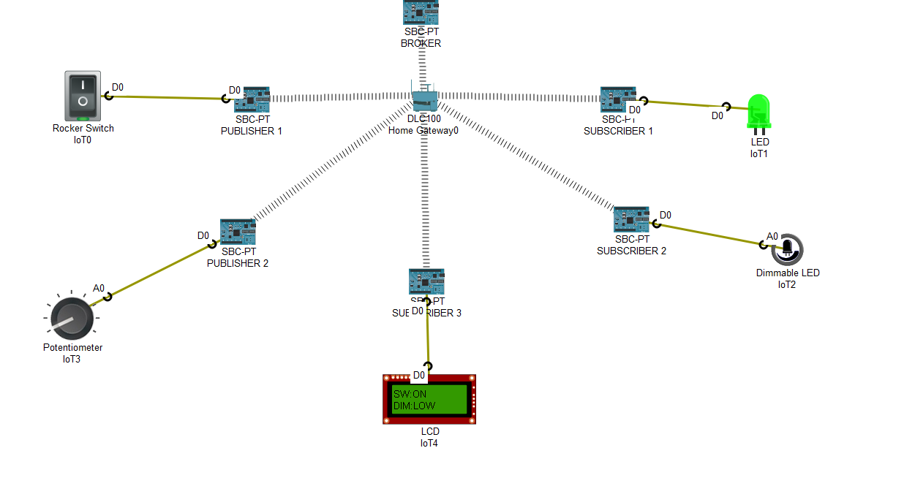

Fig-1: Switch – ON 🡪 LED - ON

Potentiometer Level – LOW 🡪 Dimmable LED - LOW

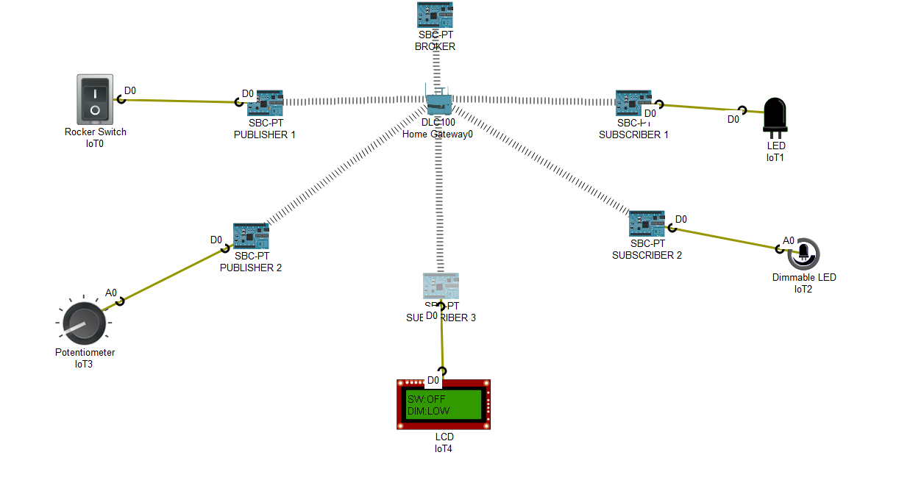

Fig-2: Switch – OFF 🡪 LED - OFF

Potentiometer Level – LOW 🡪 Dimmable LED - LOW

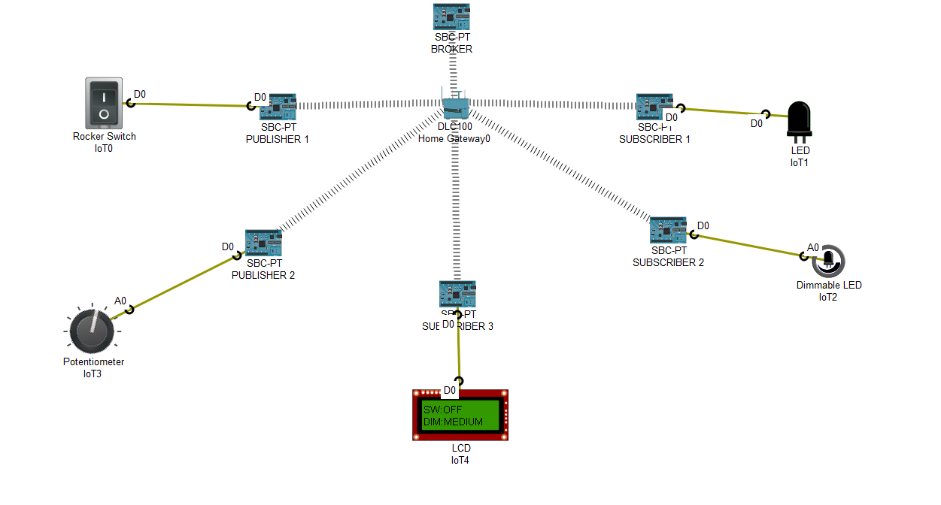

Fig-3: Switch – OFF 🡪 LED - OFF

Potentiometer Level – Mid level 🡪 Dimmable LED – Medium

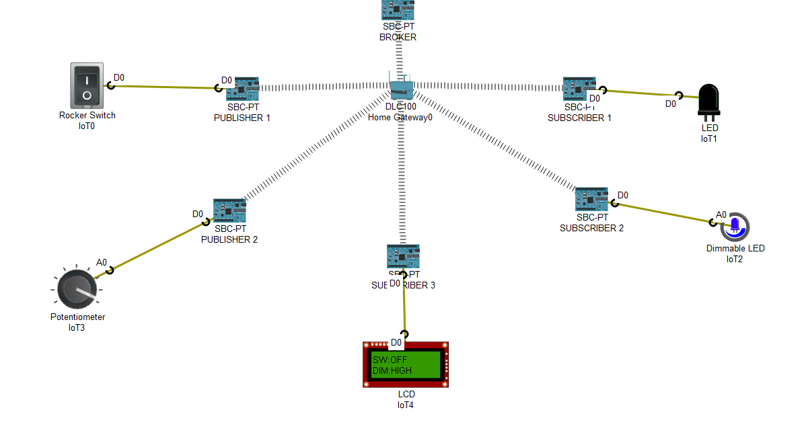

Fig-4: Switch – OFF 🡪 LED - OFF

Potentiometer Level – High level 🡪 Dimmable LED – High

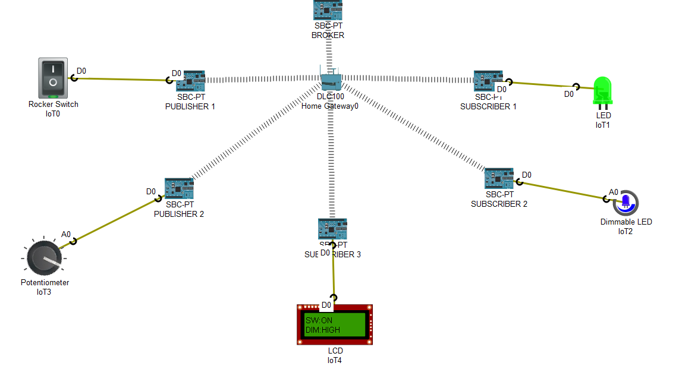

Fig-5: Switch – ON 🡪 LED - ON

Potentiometer Level – High level 🡪 Dimmable LED – High